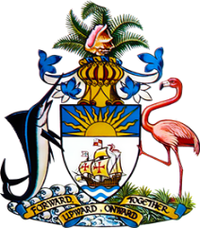

Statement by Mr. Frank Davis, Chargé d’affaires
Permanent Mission of The Bahamas to the United Nations Office and Other International Organisations in Geneva
at the 34th Session of the Universal Periodic Review Working Group
Presentation of UPR Report by the Government of Egypt
13 November 2019

Thank you, Mr. President.
While extending a warm welcome to the delegation of Egypt we commend the country for its participation in the UPR Process.

Despite areas of progress since Egypt’s last review, The Bahamas notes the ongoing challenges to democracy, the rule of law and respect for human rights reported in Egypt.
Recognizing that these values underpin the function of a peaceful and productive society, The Bahamas respectfully recommends that Egypt:

- reforms laws to ensure effective civilian oversight of military and police authorities, with special emphasis on protections from sanctioned disappearances, military trials of civilians and interference in judicial proceedings;

- reforms laws to ensure that children are not subject to severe or inhumane punishments, such as prolonged detention and capital punishment;

- reaffirms its commitment to the practice of non-refoulement and ensure that resources and support are available to vulnerable migrants; and
- strengthens its efforts in combatting Gender-based violence.
We wish Egypt a successful UPR.

I thank you.

