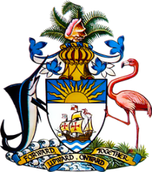

**Statement by Ms. Bernadette Butler**

**Minister-Counsellor**

**Permanent Mission of the Commonwealth of The Bahamas to the United Nations Office and Other International Organizations in Geneva**

**at the 34th Session of the Universal Periodic Review Working Group**

**Presentation of the UPR Report by the Government of Slovenia**  
**12 November 2019**

Thank you, Mr. President.

The Bahamas extends a warm welcome to the delegation of Slovenia and we commend the country for its participation in the UPR Process.

We congratulate Slovenia in its efforts to protect human rights within its borders, particularly through its ratification of the Optional Protocol on the Rights of the Child and harmonization of the Marriage and Family Relations Act with provisions of the Convention on the Rights of the Child. .

We note the continued challenges with addressing racial and ethnic discrimination, and the implementation of mechanisms to protect the rights of women and other minority groups.   
To encourage further progress, The Bahamas **recommends** that Slovenia:

1. increases public education and strengthens enforcement efforts to combat gender-based violence;
2. strengthens its efforts in combatting trafficking in persons, specifically through ensuring the provision of adequate support and rehabilitative resources to victims, and through enhanced investigation and prosecution efforts; and
3. implements stronger measures to curtail instances of racial and ethnic discrimination; discourages hate speech, and commits to sustained efforts to deter racially motivated violence, especially towards vulnerable groups.

We wish Slovenia a successful UPR.

I thank you.