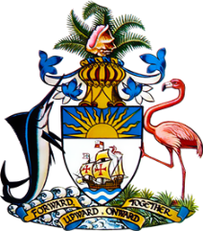

Statement by Ms. Sasha Dixon, Second Secretary
Permanent Mission of The Bahamas to the United Nations Office and other International Organizations in Geneva
on behalf of the Government of The Bahamas on the occasion of the Third Cycle UPR of the Republic of San Marino
34th Session of the Universal Periodic Review Working Group
6 November, 2019
The Bahamas extends a warm welcome to the delegation of the Republic of San Marino and congratulates the country for its ongoing efforts in the promotion and protection of human rights.
We commend the action taken by the Republic of San Marino to sign and/or ratify various international and regional human right instruments.
We also acknowledge the steps taken to combat violence against women through the introduction of new laws and related initiatives to address violence against women, gender-based and domestic violence.
We also congratulate the Republic of San Marino on the establishment of a Commission for the implementation of the UN Convention on the Rights of Persons with Disabilities.

Also noteworthy are the steps taken to ensure inclusive education for children and persons with disabilities.
With a view to encouraging further achievements, The Bahamas respectfully recommends that the Republic of San Marino:
- establishes a process to assist with the timely submission of outstanding periodic reports, through the creation of a National Mechanism for Implementation, Reporting and Follow-up (NMIRF);
- continues its efforts to ensure that all buildings are accessible for persons with disabilities; and
- establishes a procedure for the processing and adjudicating of asylum applications.

We wish San Marino a successful UPR.

I thank you.

