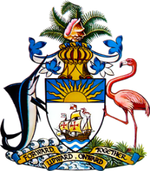

Statement by Mr. Frank Davis, Chargé d’affaires
Permanent Mission of The Bahamas to the United Nations Office and Other International Organizations in Geneva
at the 34th Session of the Universal Periodic Review Working Group
Presentation of National Report by the Government of the Republic of Fiji
6th November, 2019

Thank you [Mr./Madame] [Vice] President.
The Bahamas extends a warm welcome to its sister SIDS delegation of The Republic of Fiji.
We congratulate Fiji on ongoing efforts in the field of human rights as well as its leadership on the issue of climate change. We highlight the following significant achievements: The establishment of a robust legislative and policy framework both in relation to disaster response and to building strong and resilient communities; the launching of its first National Adaptation Plan outlining strategic progressive strategies to ensure an inclusive and systematic approach to climate adaptation; the formation of the Planned Relocation Guidelines; its successful implementation of the pilot project, First Hour Procedure after ratifying the Convention Against Torture (CAT), ensuring the provision of counsel to every suspect within their first hour of arrest and achieving the goal of ratifying the nine core human rights treaties by 2020.
With a view to encouraging further progress, The Bahamas respectfully recommends that Fiji:
- follows through with its commitment to establish a National Mechanism for Implementation, Reporting and Follow-Up on human rights recommendations and commitments;
- strengthens its efforts to eliminate racial discrimination; and
- revises its building codes to increase resilience in light of more frequent and intense weather systems resulting from climate change and so as to safeguard its commitment to the human rights to adequate housing, sanitation, and clean water.
We wish Fiji a successful UPR.
I thank you.

