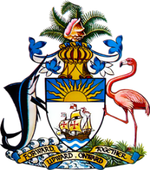

Statement by Ms. Sasha Dixon, Second Secretary
Permanent Mission of The Bahamas to the United Nations Office and Other International Organisations in Geneva
at the 34th Session of the Universal Periodic Review Working Group
Presentation of UPR Report by the Government of Bolivia
5 November 2019

Thank you, Mr. [Vice] President.
The Bahamas extends a warm welcome to the delegation of Bolivia and we commend the country for its commitment to strengthening the promotion and protection of human rights for its people.

We congratulate Bolivia on significant strides made in the areas of reducing poverty, unemployment and income inequalities as well as increased public expenditure on health and education, including efforts toward achieving universal health coverage. Bolivia has also prioritized improving access to justice, combating corruption and efforts to fight against femicide and violence against women. We also note, with interest, the complementary policies and plans that have been developed in these areas.

We further welcome Bolivia’s efforts in the area of promoting clean energy and Bolivia’s development of a National Mechanism for Implementation, Reporting and Follow-up (NMIRF).
To encourage further progress, The Bahamas recommends that Bolivia:

- strengthens the Plurinational Public Defender Service and provides it with adequate and sustainable resources to fulfil its mandate;
- fully implements the 2013 Act on Guaranteeing a Life Free of Violence for Women and strengthens relevant national institutions with adequate and sustainable budgetary, staff and technical resources, and,
- takes steps to reduce poverty rates for persons living with disabilities and female-headed households.
We wish Bolivia a successful UPR.

I thank you.

