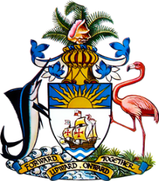

Statement by Mr. Frank Davis, Chargé d’Affaires
Permanent Mission of The Bahamas to the United Nations Office and Other International Organisations in Geneva
at the 34th Session of the Universal Periodic Review Working Group
Presentation of UPR Report by the Government of El Salvador
4 November 2019

Thank you, Mr. President.
The Bahamas extends a warm welcome to the delegation of El Salvador and we commend the country for its commitment to this UPR process.

We congratulate El Salvador on strides made in the field of human rights and, in this regard, we would highlight the numerous laws enacted to bring domestic legislation in line with international human rights standards as well as the comprehensive set of policies and plans which complement these.

Ongoing work in the area of preventing violence among youth, the holistic and multi-sectoral approach taken to combating violence against women as well as increases in the budgetary allocations for education and health are indeed commendable.

We also particularly welcome El Salvador’s progress in strengthening the legislative and policy environment in responding to climate change, one of the greatest threats to human rights of our time.
To encourage further progress, The Bahamas recommends that El Salvador:

- prioritizes ensuring the right to clean water and sanitation for all, including in rural areas;
- strengthens the national strategy to address climate change including establishing a mechanism to respond to future droughts, and,
- adopts a comprehensive strategy to address discrimination against persons of African Descent including awareness-raising campaigns to promote tolerance and respect for diversity.
We wish El Salvador a successful UPR.

I thank you.

