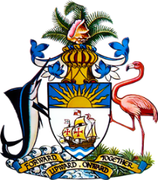

Statement by Mr. Frank Davis, Chargé d’Affaires
Permanent Mission of The Bahamas to the United Nations Office and Other International Organisations in Geneva
at the 34th Session of the Universal Periodic Review Working Group
Presentation of UPR Report by the Government of Italy
4 November 2019

Thank you, Mr. President.
We warmly welcome the delegation of Italy and commend the country for its commitment to the UPR process.

Noteworthy are Italy’s efforts in the area of countering violence against women, such as the development of the National Strategic Plan on male violence against women, 2017-2020; the State Police’s ‘EVA Protocol' and ‘Guidelines on Preventive measures’ aiming to identify possible cases of domestic violence protect victims.

Policies to combat discrimination are also significant, such as the National Plan of Action against Racism, Xenophobia and Related Intolerance and the National Action Plan against Trafficking.

We also welcome Italy’s commitment to achieving the ODA target of 0.7 per cent of GNI.
To encourage further progress, The Bahamas recommends that Italy:

- fully implements the recommendations made by the Working Group of Experts on People of African Descent following the mission to Italy in June 2015;
- fully implements the Plan of Action against Racism, Xenophobia and Related Intolerance and ensure adequate and sustainable human and financial resources to do so, and,
- takes concrete steps to improve access to education and employment for persons with disabilities.

We wish Italy a successful UPR.

I thank you.

