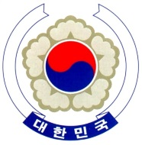
PERMANENT MISSION OF THE REPUBLIC OF KOREA
GENEVA
The 34th Session of the UPR Working Group <Check against delivery>
Review of Iran (Islamic Republic of)
Geneva, 8 November 2019

Statement of the Republic of Korea

Mr. President,
The Republic of Korea welcomes the delegation of Iran to its third cycle of the UPR.
The Republic of Korea notes with appreciation that Iran has adopted and revised various domestic laws to protect and promote human rights in the country. Also, we commend Iran on its efforts to provide a large number of refugees with education, medical services and vocational training in cooperation with international organizations.
The Republic of Korea would like to present the following recommendations to Iran:
- Consider the ratification of human rights instruments to which Iran is still not a party, in particular CEDAW and CAT;
- Strengthen its efforts to prevent and eradicate discrimination against religious and ethnic minorities; and
- Fully implement relevant laws to hold to account perpetrators of intimidation and reprisals against human rights defenders and journalists.
The Republic of Korea wishes Iran a successful UPR. Thank you. /End/

