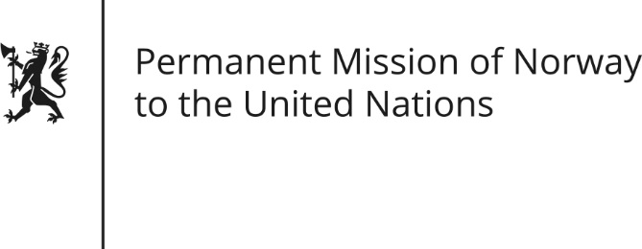

STATEMENT by First Secretary Sean Lobo

34th Session of the Universal Periodic Review

Madagascar

11 November 2019

Check against delivery

President,
Norway is encouraged by Madagascar’s recent free and fair elections and the progress towards a state characterized by rule of law.
Despite introduction of relevant policies and measures by the state, the majority of Malagasy children do not get their right to education fulfilled. [In 2012 it was estimated that more than 200 000 children affected by disabilities were excluded from the education system.]
Sexual and gender based violence is a serious problem. [We welcome the renewed efforts by the authorities and its UN partners to respond to the victims and the drafting of relevant legislation.]
Norway recommends that Madagascar:
- Accelerate efforts to reach the objectives on inclusive education in the national sector plan, especially with regard to children with disabilities and children in geographically isolated areas.
- Approve the proposed bill to combat gender-based violence, and ensure adequate resources for its implementation, including effective handling of martial rape as a criminal offence.
Thank you.

