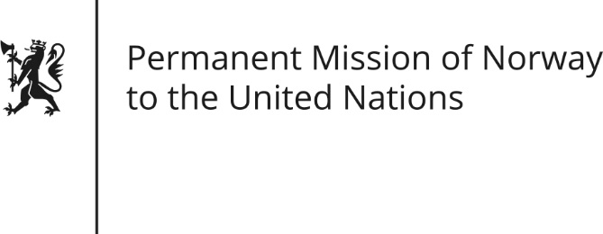

STATEMENT by Minister Counsellor Anniken Enersen

34th Session of the Universal Periodic Review

Italy

4 November 2019

Check against delivery

President,
Ensuring a person’s right to an effective remedy by competent national tribunals for acts violating rights, is fundamental in protecting the human rights - and therefore a priority to Norway.
Norway recommends that Italy:
- Continue to review and implement criminal and civil justice procedures in order to improve the efficiency of the judiciary.
- Promote gender equality, including combatting discrimination based on sexual orientation, and strengthening the protection of victims of domestic abuse.
- Undertake further initiatives to address hate speech directed against members of vulnerable groups, and ensure sufficient focus on this topic in the education system.
- Continue efforts to preserve and protect freedom of speech, especially if it concerns journalists and authors investigating sensitive topics such as corruption, mafia activity and political entities.
Thank you.

