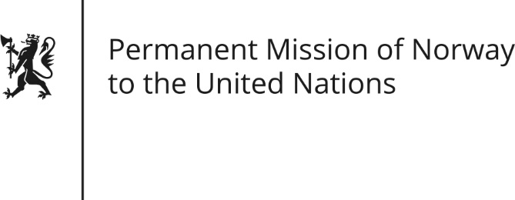

STATEMENT by First Secretary Sean Lobo

34th Session of the Universal Periodic Review

Iraq

11 November 2019

Check against delivery

Norway commends Iraq for the positive steps taken to enhance women’s participation in the workforce, particularly through the 2015 Labor Law.
Norway is concerned about the recent developments in Iraq and the excessive use of force against protesters and emphasizes the right to peaceful protest. [Norway also remains concerned about the human rights development in the aftermath of the war against ISIL. ]
Norway recommends that Iraq:
1) Establish an immediate moratorium on the death penalty with a view to its abolition.
2) Investigate promptly all allegations of torture and ill-treatment, and facilitate visits by the Special Rapporteur on the question of torture to all detention facilities in Iraq.
3) Release from detention all children who have not formally been charged with a crime, apply international juvenile justice standards, and ensure that the treatment of children in prison complies with the Convention of the Rights of the Child.
4) Amend the domestic legislation to bring it into compliance with CEDAW, [including repealing sub‐section 1 of Article 41 of the Iraqi Penal Code.]
5) [Provide protection and ensure the rights of all displaced persons, regardless of perceived political affiliations, in accordance with the UN Guiding Principles on Internal Displacement.]

Thank you

