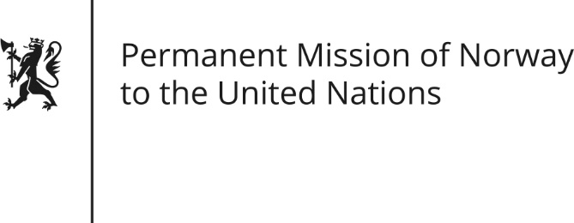

STATEMENT by Øystein Egeland

34th Session of the Universal Periodic Review

Iran

8 November 2019

Check against delivery

President,
Norway notes positive steps taken [since its last review], including the reduction of the number of capital punishments. [Norway also welcomes the progress on securing education and health care for Afghan nationals in Iran.]
Norway urges Iran to improve the human rights situation in accordance with international standards and Iran’s own commitments.
Norway recommends that Iran:
- Abolish the death penalty, and stop planned executions for persons who committed crimes before the age of 18.
- Ensure the freedom of religion and belief for [religious] minorities such as the Bahai’s and Christian converts, by adopting concrete measures to eliminate discrimination and enhance protection.
- Create a safe and enabling environment for civil society and human rights defenders, especially women human rights defenders.
- Ensure the rights of detainees and prisoners, and their right to receive satisfactory medical treatment.
- Cease the censorship of the media, as well as the arbitrary detention and intimidation of journalists [in order to ensure freedom of expression].
Thank you.

