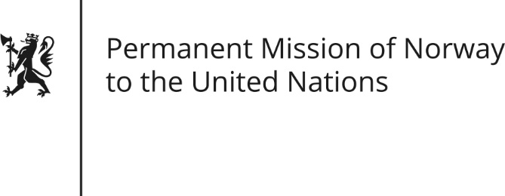

STATEMENT by Axel Wedén

34th Session of the Universal Periodic Review

El Salvador

4 November 2019

Check against delivery

President,
Norway welcomes El Salvador’s participation in the UPR and notes the positive steps taken since its last review, including the government’s commitment to combat violence and to strengthen women’s rights.
However, Norway remains concerned about El Salvador’s legislation on abortion, and the high level of violence and homicides.
Norway recommends that El Salvador:
- Guarantee women’s sexual and reproductive health and reproductive rights, by amending legislation on abortion, in a transparent consultation process that includes civil society.
- Confront the origins of violence and crime in a comprehensive manner, including by implementing a restorative justice approach, by fully investigating all human rights violations and ensuring that those responsible are brought to justice.
- Ensure transparent, independent and impartial investigations of cases involving violence against women and LGBTI persons.
- Undertake an inclusive process with a wide range of civil society representatives when implementing the UPR recommendations.
Thank you.

