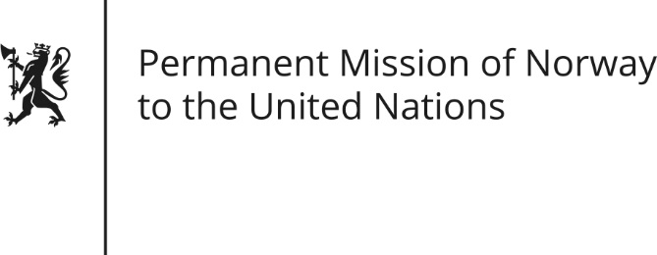

STATEMENT by Maria Hunskaar

34th Session of the Universal Periodic Review

Egypt

13 November 2019

Check against delivery
President,
Norway notes the positive steps taken by Egypt since its last review, [including the adoption of the National Strategies for Women’s Empowerment and to Combat Violence against Women.
Norway remains concerned about the limited space for peaceful expression of civil discontent and its impact on Egypt’s long-term stability.]
Norway recommends that Egypt:
1) Issue standing invitations to all special rapporteurs, especially those on the Situation of Human Rights Defenders, and Torture [and Other Cruel, Inhuman or Degrading Punishment or Treatment.]
2) Guarantee that freedom of expression is ensured in all its forms, including artistic expressions, online and offline.
3) Ensure the protection of all citizens against torture and other cruel, inhumane or degrading treatment or punishment, and provide the police and armed forces with the necessary training [so that they act in accordance with international human rights norms].
4) Impose a moratorium on executions with a view to abolish the death penalty.
5) Identify all juveniles tried in adult courts, overturn those verdicts and refer all such defendants to juvenile courts.

Thank you.

