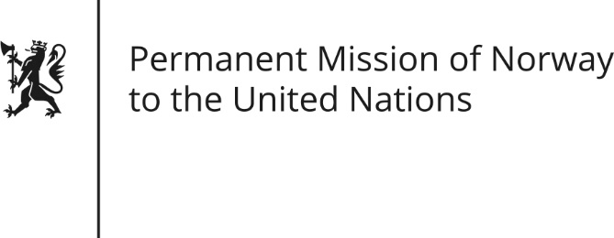

STATEMENT by Arild Moberg Sande

34th Session of the Universal Periodic Review

Bosnia and Herzegovina

13 November 2019

Check against delivery

President,
Norway welcomes Bosnia and Herzegovina’s participation in the UPR, and notes the positive steps taken since the last review, including freedom of assembly for the LGBTI communities, (and strengthening institutional capacities and legal provisions for women’s rights and gender equality).
We welcome the news that the article on death penalty has been formally repealed from the Constitution of the Entity Republika Srpska, thus confirming BiH as an abolitionist country.
Norway recommends that Bosnia and Herzegovina:
1) Take action to end segregation in the education system and ensure equal access to quality education for all, including national minorities and children with disabilities.
2) Intensify efforts to investigate threats and attacks against journalists, and take measures to ensure the safety of journalists and media workers.
3) Remove obstacles for national minorities to effectively exercise their political rights (and align its Constitution with the ECHR (European Convention of Human Rights)).

Thank you.

