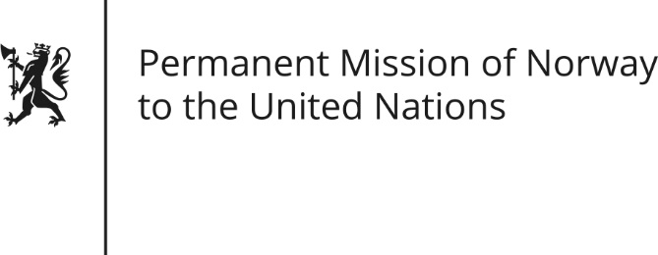

STATEMENT by Ellen Aabø

34th Session of the Universal Periodic Review

Angola

7 November 2019

Check against delivery

President,
Norway commends Angola’s progress towards a more open and democratic society [since the last review. The new government has made significant efforts to strengthen human rights though the legal and policy frameworks, [including a new Penal Code, ratification of key human rights conventions and the upcoming National Human Rights Strategy.] Norway appreciates our close collaboration with Angola, [which aims to promote human rights and sustainable development.]
Norway recommends that Angola:
- Take concrete steps to make independent media accessible nationwide, including by reducing the cost of broadcasting licenses.
- Ensure effective countrywide implementation of the Law on Domestic Violence and continues to strengthen women's rights countrywide.
- Develop a National Action Plan for the implementation of the United Nations Guiding Principles on Business and Human Rights, and continues to consider joining the Extractive Industries Transparency Initiative.
- Put in place institutional mechanisms that can effectively protect LGBTI-persons against all forms of violence, harassment and discrimination.
- Guarantee equal access to justice for all, by taking concrete measures to strengthen institutional mechanisms.
Thank you.

