Check against delivery
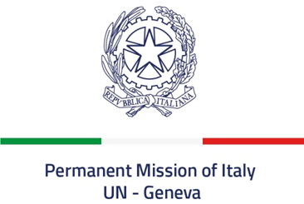
Universal Periodic Review – El Salvador
4 November 2019

Thank you Mr. President.

Italy welcomes the distinguished Delegation of El Salvador.
Italy welcomes the ratification of the Rome Statute of the International Criminal Court and the withdrew of the reservation made by El Salvador to the Convention Against Torture and Other Cruel, Inhuman or Degrading Treatment or Punishment. Italy also welcomes:
- the improvements made since the last review cycle in the domain of a more effective protection and non-discrimination of LGBTI persons, both at legislative and at awareness raising level;
- the appointment of Mr. José Apolonio Tobar as the new Attorney General for the protection of Human Rights
Mr. President,
Italy seizes this opportunity to offer El Salvador the following recommendations:

- Take further measures to promote the respect of children’s rights, including by fighting against child labor and by implementing the measures aimed at preventing child, early and forced marriages.
- Engage in preventing all episodes of torture, arbitrary detentions, enforced disappearance as well as excessive use of the force by the police forces, also by ratifying the UN Convention for the protection of all persons from enforced disappearance and the Optional Protocol to the UN Convention against torture.
- Fully implement the existing legislation on the protection of women against all forms of violence and discrimination, strengthen the efforts to fight domestic violence and decriminalize abortion when the life of the mother is at risk and/or the pregnancy is the result of rape.

Italy wishes El Salvador a successful review.

Thank you.

