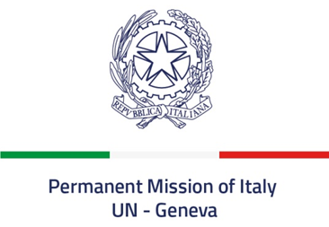
Check against delivery
Universal Periodic Review – Bosnia and Herzegovina
November 13, 2019

Thank you Mr. President.

Italy welcomes the Delegation of Bosnia and Herzegovina.
Italy welcomes the adoption of the Action Plan to combat human trafficking and related amendments to the criminal code, as well as introduction of the offence of enforced disappearance as an autonomous crime.
Italy also welcomes the amendments made since the previous review’s cycle to the law on prohibition of discrimination, that extended the listed grounds for discrimination to age, disability, sexual orientation and gender identity.
Mr. President,
Italy seizes this opportunity to offer Bosnia and Herzegovina the following recommendations:

- Take all the necessary measures to foster intercultural dialogue, tolerance and understanding among the different communities, including by enabling positive environment for reconciliation and for the protection and inclusion of all vulnerable groups.
- Ensure that access to justice is assured to every citizen, including by providing free legal assistance to the most vulnerable groups and by fully implementing anti-corruption policies.
- Take measures to strengthen the inclusiveness of the education system, including by facilitating access to education for Roma children and children with disabilities.
- Remove obstacles for the achievement of full political, economic, and social participation of women.

Italy wishes Bosnia and Herzegovina a successful review.

Thank you.

