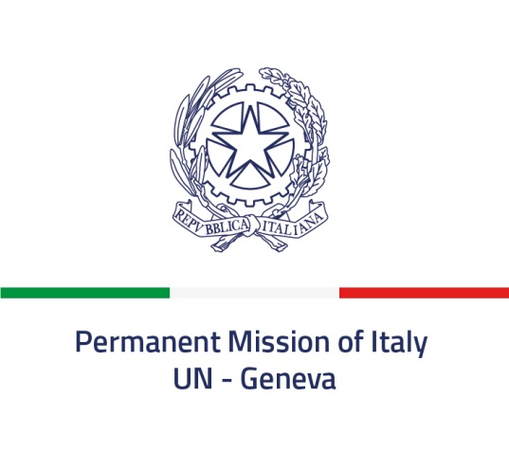
34th Universal Periodic Review – Ad referendum adoption of the report on Italy
(8 November 2019)

Thank you, Mr President,

I would like to seize this opportunity to warmly thank, on behalf of the Italian Authorities, the 121 delegations that actively participated in our UPR review last Monday, also for their support and recommendations.

I also would like to express our deep appreciation to the OHCHR Secretariat for its most valuable work and advice, to the Troika members, namely Slovakia, Australia and South Africa for their remarkable and tireless efforts for the completion of our report, to the Conference service and, last but not least, to the interpreters.

As mentioned earlier this week, much has changed globally and domestically. We reiterate our conviction that the challenges ahead do require joining forces more and further within the UN system and in light of the UN Charter and Universal Declaration of Human Rights.

Against this background, the UPR allows for a constructive dialogue, follow-up actions and a stronger inclusive implementation of human rights commitments and obligations.

Italy firmly supports the UPR Mechanism as a key instrument of the UN Human Rights Machinery and, needless to say, of this Council.

The process initiated three Cycles ago, the on-going increasingly stronger dialogue and the recommendations listed in the report before us today allow to reflect on the way forward.

We will examine the list of recommendations carefully in the coming months. The relevant Ministries will assess and consider the recommendations within their respective area of responsibility.

The Inter-ministerial Committee for Human Rights (in Italian, CIDU) is the main coordination body (National Mechanism for Reporting and Follow-up) in Italy for integrated reporting to recommendations by the UN human rights mechanisms. We will spare no efforts to ensure that increasing multi-stakeholder and result-oriented action will be devoted to this end.

We will indicate our position at the next Human Rights Council’s session. But allow me to reiterate that we do look forward to continuing this dialogue, increasingly aimed at improving and ensuring human rights, for all.

Once again,

I thank you, Mr. President.

