ITALY

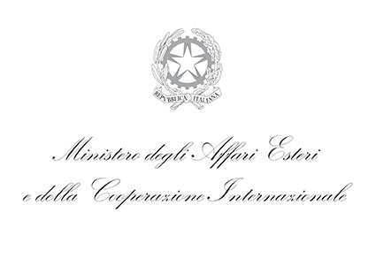
Inter-ministerial Committee for Human Rights
Comitato Interministeriale per i Diritti Umani

CONCLUDING REMARKS
BY H.E. HON. Mr. MANLIO DI STEFANO,
UNDER-SECRETARY OF STATE
FOR FOREIGN AFFAIRS OF ITALY,
ON THE OCCASION OF THE REVIEW OF ITALY,
UNIVERSAL PERIODIC REVIEW – CYCLE 3
(34TH SESSION, GENEVA)

Geneva, November 4th, 2019

Thank you, Mr. President, Amb. Coly Seck,

Distinguished delegates, Ladies and Gentlemen,

Before replying to the last set of questions, on behalf of the Italian delegation and myself, allow me to thank, most sincerely, all the delegations that took the floor today for their active participation in the UPR of Italy.

We also acknowledge with appreciation the participation of delegates of several Small Island Developing States and Least Developed Countries – and Italy is proud to be one of the main donors of the Technical Trust Fund, which supports their participation in the work of the Human Rights Council.

Likewise I would like to express my sincere gratitude to the UPR Secretariat, the Conference Service and, last but not least, the interpreters - with their unique ability to reproduce any type of speech, including ours. All the UN staff members have ensured the efficient and smooth proceeding of our Review.

I also would like to emphasise, on behalf of the Italian delegation, that it has been a great honour to provide you, with further information, clarifications and explanations about the on-going efforts of my Country. As mentioned earlier today, since the previous Review (October 2014), much has changed globally and within our respective countries. The challenges ahead of us do require joining forces more and further but we are also fully convinced that within the UN system and in light of the UN Charter and Universal Declaration of Human Rights, we will be much better able to ensure all together, the way forward.

To conclude, by recalling our motto “Human Rights for Peace”, we will continue to spare no efforts to effectively promote human rights, in light of the principles of universality, indivisibility, and inter-relatedness of human rights, to be recognized and guaranteed to each individual without any distinction.

We remain profoundly committed to ensuring that the three pillars of the UN Charter continue reinforcing each other, especially within the UN Sustainable Development Goals framework. Allow me also to reiterate that Italy is particularly committed to fully promoting and protecting human rights domestically.

The Inter-ministerial Committee for Human Rights (in Italian, CIDU), and its President - Min. Plen. Fabrizio Petri, sitting next to me today – is particularly engaged since CIDU is the main coordination body (National Mechanism for Reporting and Follow-up) in Italy for integrated reporting to recommendations by the UN human rights mechanisms. We will spare no efforts to ensure that increasing multi-stakeholder and result-oriented action will be devoted to this end.

I do thank you.

