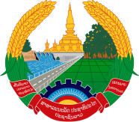
Statement by the delegation of the Lao PDR
At the 33rd Session of UPR Working Group of Human Right Council
Geneva, 6 - 17 May 2019

Review of the Nicaragua: 15 May 2019

Mr. President,
The Lao delegation welcomes and thanks the delegation of Nicaragua for the presentation of its national report on the development of human rights.

We commend the Government of Nicaragua for the achievements made in promoting and protecting human rights for its citizen through many initiatives including the National Human Development Plan. We particularly welcome the public policies to improve the social and education rights for women, children and elderly people.

Taking this opportunity, we would like to make the following recommendations:

- First, continues its guaranteed education programmes that aims to improve the quality education, equitable access and increase the institutional efficiency and effectiveness; and

- Second, continues its priority to support gender equality and the participation of women in decision-making levels.

We wish Nicaragua all the success its review.

I thank you, Mr. President.

