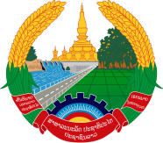

Statement by the delegation of the Lao PDR
At the 33rd Session of UPR Working Group of Human Right Council
Geneva, 6 - 17 May 2019

Review of the Qatar: 15 May 2019

Mr. President,
The Lao delegation would like to welcome the delegation of Qatar and congratulate for its comprehensive UPR report presented to the council.

We welcome the progress of Qatar’s efforts in implementing its national strategies and policies, such as the Qatar National Vision of 2030 and the Second National Development Strategy to promote and protect human rights in the country, especially the right of women and children.

In this connection, we would like to recommend the following:

- Continues its efforts to further enhance gender equality and women’s empowerment in both public and private administration; and
- Continues to support children enrollment in school to develop skills in various fields through sound education in order to help the poor and other vulnerable groups, including in rural society to improve their skills and have better access to economic opportunities as well as basic services.

We wish Qatar a very success in its review.

I thank you, Mr. President.

