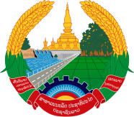

Statement by the delegation of the Lao PDR
At the 33rd Session of UPR Working Group of Human Right Council
Geneva, 6 - 17 May 2019

Review of the Dominica: 9 May 2019

Mr. President,
The Lao delegation welcomes and thanks the delegation of Dominica for the comprehensive presentation of its national report on the development of human rights.

We commend efforts of the Government of Dominica in implementing its commitments to ensure the promotion and protection of the rights of all Dominicans. We particularly welcome the National Gender Policy aims at promoting and protecting women and child’s rights on equal basis.

In this connection, we would like to make the following recommendations:

- First, continue to work towards empowerment of women and their integration in the society; and
- Second, continue to deliver quality education for all children.

We wish Dominica a very successful review.

I thank you, Mr. President.

