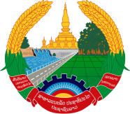
Statement by the delegation of the Lao PDR
At the 33rd Session of UPR Working Group of Human Right Council
Geneva, 6 - 17 May 2019

Review of the Ethiopia: 14 May 2019

Mr. President,
The Lao delegation warmly welcomes and thanks the delegation of Ethiopia for presenting its national report on the development of human rights.

We commend the Government of Ethiopia for the achievements made in promoting and protecting human rights for its citizen in the past years, including through implementation of the National Social Protection Policy with focus on children, women, people with disabilities and elderly people.

In this connection, we would like to make the following recommendations:

- First, continues its education programmes to ensure equitable access to quality education at all levels; and

- Second, continues to support and encourage the participation of women in politics platforms both in regional and national levels.

We wish the Ethiopia all the best in its review.

I thank you, Mr. President.

