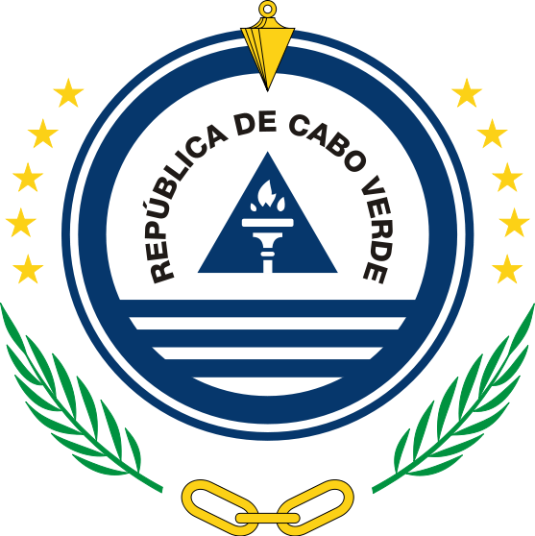

**Mission permanente de la République de Cabo Verde**

33 Session of the UPR Working Group on the Universal Periodic Review

(07 – 1 February 2019)

**Review of Etiopia**

**Intervention of Cabo Verde**

Maria de Jesus Veiga Miranda Ambassador / Permanent Representative

I Thank You, Mr Vice-President

The Delegation of Cabo Verde welcomes and thanks the Etiopian delegation for submitting its national report.

We commend Etiopia on the establishement of a national mechanism for reporting and follow-up on the implementation of the recommendations made during the second cycle of the UPR and for incorporating all acepted UPR recommendations in its National Human Rights Action Plan.

We respectfully recommend Etiopia the following

1. To integrate the human rights recommendations implementation plan with the SDGs reporting ;
2. To extend a standing invitation to all Human Rights Special Procedures mandate holders ;
3. To take all measures to completely eliminate FGM (Female Genital Mutilation), Child Mariage;
4. To improve national legislation on free and compulsory Education

We wish Etiopia plenty success in this review and in the implementation of accepted recommendations.

Thank you