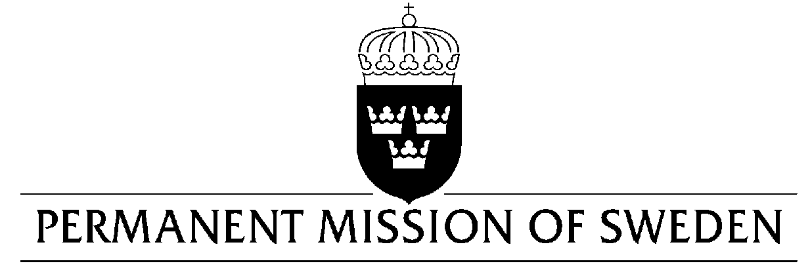
UN Human Rights Council

UPR 33rd session

Statement by Sweden in the interactive dialogue on Brunei Darussalam

Delivered by Second Secretary Clara Molin
Geneva, 10 May 2019 (speaking time 0.47 min, speaker no .76)

Mr. President,

Sweden strongly opposes the death penalty, in all times and circumstances and is deeply concerned over the recently introduced legislation on death penalty by stoning and other cruel and inhuman punishments. The new legislation violates international human rights law, and Sweden would therefore like to make the following recommendation:

- To revoke immediately the new legislation from April 3rd 2019 that imposes the use of death penalty for homosexuality and adultery and introduces other cruel and inhuman punishments.

Sweden wishes Brunei all success in the current review.

I thank you Mr. President.

