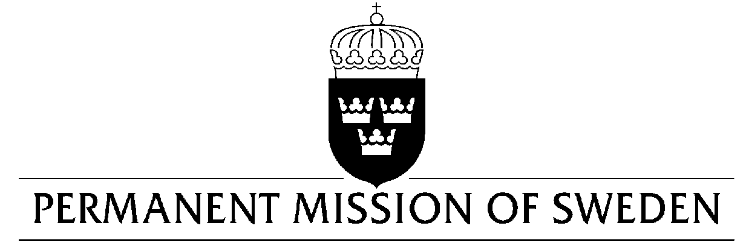
UN Human Rights Council

UPR 33rd session

Statement by Sweden in the interactive dialogue on Norway

Delivered by Ambassador Veronika Bard
Geneva, 6 May 2019 (speaking time 1:05 min, speaker no. 76)

Mr. President,

Sweden commends Norway for its long-standing commitment to the protection and promotion of human rights, nationally and internationally. Sweden warmly welcomes the efforts made since the last UPR-cycle, for example the new Equality and Anti-Discrimination Act adopted in January 2018 and the new non-custodial sanction in 2014. However, we note concerns raised regarding gender-based violence, incitement to hatred and the conditions in prisons, and would therefore like to make the following recommendations:

- To strengthen the investigation capacity of law enforcement officials on hate crimes and criminal incitement to hatred, including on the internet.

- To implement all necessary measures to prevent and eliminate gender-based violence against women and girls and ensure that perpetrators are prosecuted and punished.

- To evaluate the effects of solitary confinement in prisons with a view to reducing it and use alternative measures whenever possible.

Sweden wishes Norway all success in the current review.

I thank you Mr. President.

