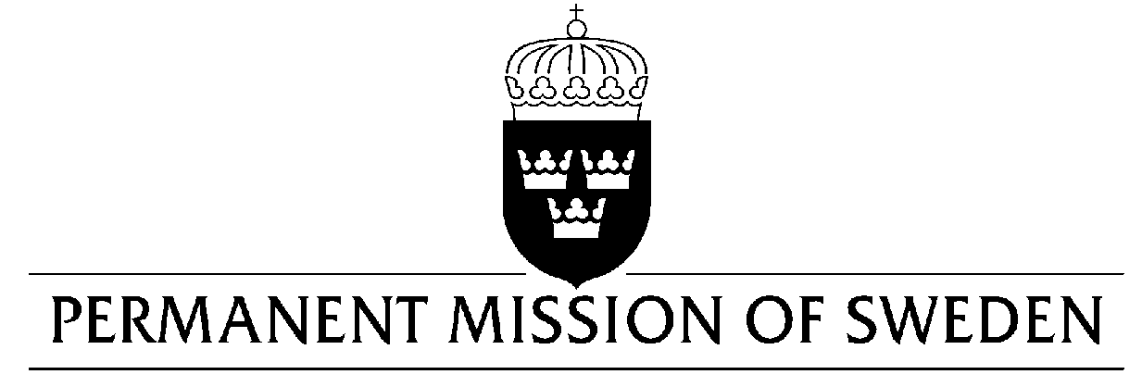
UN Human Rights Council

UPR 33rd session

Statement by Sweden in the interactive dialogue on Nicaragua

Delivered by Second Secretary Clara Molin
Geneva, 15 May 2019 (speaking time 1:20 min, speaker no.54)

Mr. President,

Sweden acknowledges the agreements signed on March 29 2019, in which the Government of Nicaragua has made commitments concerning political prisoners and freedom of association. However, Sweden remains concerned about the implementation of agreed commitments and the sustainability of the national dialogue as well as the deteriorating human rights situation in the country, especially related to the freedom of expression, peaceful assembly and association, measures to criminalize civil society and undermine the rule of law. Sweden would therefore like to make the following recommendations:

- To undertake independent investigations into all reported incidents of attacks, intimidation or harassment of journalists since April 2018.

- To reform legislation which is used to detain and prosecute demonstrators and human rights defenders, especially to reconsider charges of terrorism under Act 977 and assure that the offence cannot be extrapolated to situations unrelated to the aim of the Act.

- To accede to the Rome Statute of the International Criminal Court.

- To take all necessary actions to implement the recommendations of the OHCHR and GIEI reports regarding the independence and impartiality of the judiciary.

Sweden wishes Nicaragua all success in the current review.

I thank you Mr. President.

