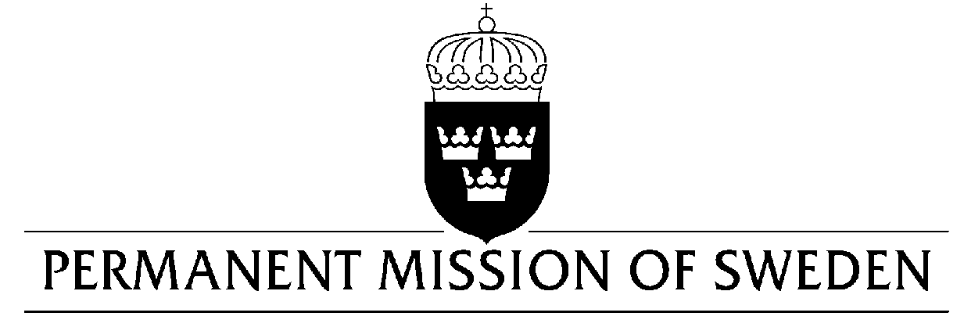
UN Human Rights Council

UPR 33rd session

Statement by Sweden in the interactive dialogue Portugal

Delivered by Second Secretary Clara Molin
Geneva, 8 May 2019 (speaking time 0:57 min, speaker no. 30)

Mr. President,
Sweden commends Portugal’s commitments to the protection and promotion of human rights and warmly welcomes positive developments regarding the strengthening of LGBTI- persons full enjoyment of human rights. However, we remain concerned about the domestic violence against women, the conditions inside prisons and the situation for Roma. Sweden would therefore like to make the following recommendations:

- To facilitate prosecution of domestic violence by strengthening measures for victim protection, in order to ensure that laws prohibiting violence against women are fully enforced.

- To take measures to reduce overcrowding in prisons, particularly through the wider application of non-custodial measures as an alternative to imprisonment.

- To improve access to housing, education and employment for individuals of the Roma communities, in order to fight racial discrimination and improve integration.

Sweden wishes Portugal all success in the current review.

I thank you Mr. President.

