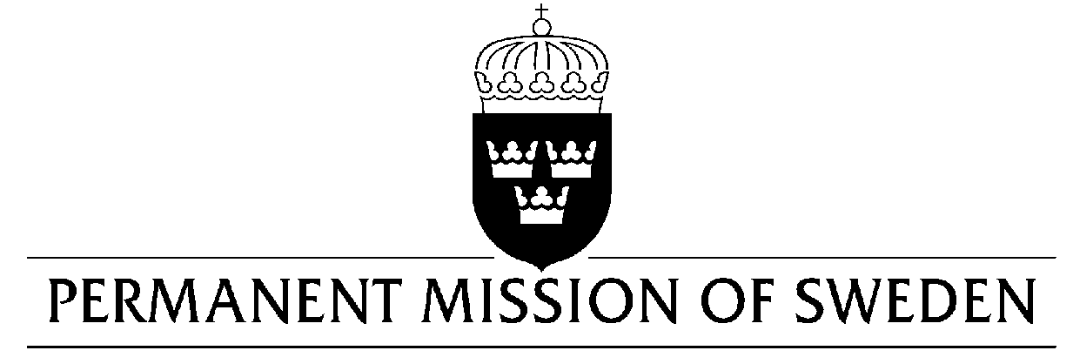
UN Human Rights Council

UPR 33rd session

Statement by Sweden in the interactive dialogue on Qatar

Delivered by Minister-Counsellor Oscar Ekéus
Geneva, 15 May 2019 (speaking time 1:05 min)

Mr. President,

Sweden welcomes the improvements related to migrant workers’ enjoyment of human rights since the last UPR-cycle, and appreciates the good cooperation between ILO and the Government of Qatar. However, continued efforts for the strengthening of human rights are still needed. Sweden makes the following recommendations:

- To reform laws that discriminate against women and girls to ensure that all legislation and policies, including the family law, the laws regulating sexual and reproductive health, laws relating to the authority of guardians over women, inheritance and nationality, conform to international human rights law and standards.
- To continue its efforts to reform the rights of workers to reduce the risk of migrant workers being subjected to forced labour, including by removing the requirement for migrant workers to obtain the permission of their current employer before moving to a new job, and to abolish the requirements for an exit visa for all workers.
- To take immediate measures to ensure that the Cybercrime Prevention Law and the penal code do not restrict the constitutional right to freedom of expression.

Thank you Mr. President

