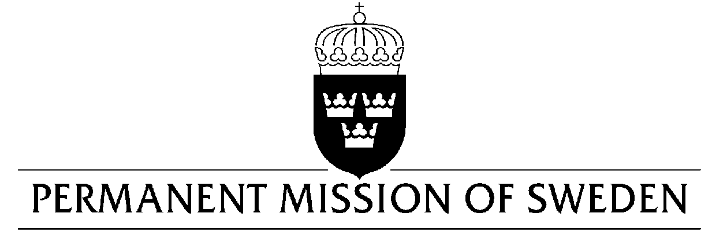
UN Human Rights Council

UPR 33rd session

Statement by Sweden in the interactive dialogue on Ethiopia

Delivered Ambassador Veronika Bard, Geneva, 14 May 2019 (speaking time 0:55 min)

Mr President,

The Government of Ethiopia has taken important decisions to enhance regional peace and development as well as domestic democratic reforms. Sweden encourages these efforts and makes the following recommendations:

1. To fully uphold humanitarian principles by ensuring that humanitarian actors have unhindered access to those in need, particularly internally displaced persons, and that return and re-settlement is conducted through safe, informed, dignified and voluntary relocation.

2. To adopt a comprehensive and inclusive law on gender-based violence, addressing all forms of violence against women and girls.

3. To amend the Criminal Code (2005) with a view to increase the penalties for female genital mutilation, criminalize marital rape and exclude the applicability in domestic violence cases of the extenuating circumstances.

4. To formally abolish the death penalty by removing capital punishment from the penal code.

Sweden wishes Ethiopia all success in the current review.

I thank you Mr. President.

