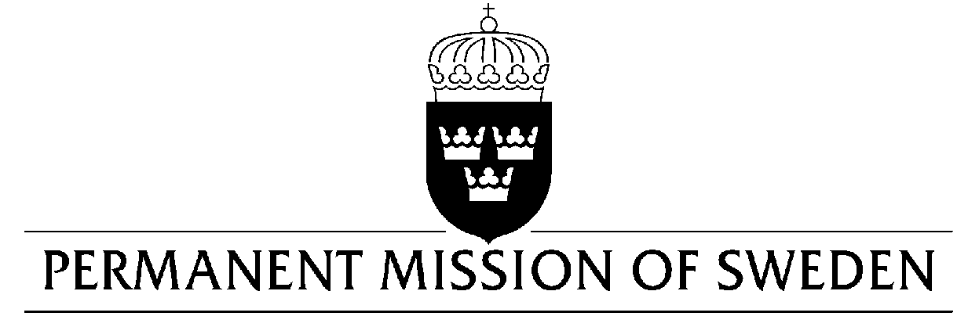
UN Human Rights Council

UPR 33rd session

Statement by Sweden in the interactive dialogue on the Democratic People’s Republic of Korea

Delivered by Ambassador Veronika Bard
Geneva, 9 May 2019 (speaking time 1:20 min, speaker no. 90)

Mr. President,
Sweden recognises the importance of the ongoing negotiations regarding denuclearisation and peace on the Korean peninsula, where human rights should be at the heart of the process. Sweden welcomes the submission of the DPRK’s report on the implementation of the Convention on the Rights of Persons with Disabilities. However, Sweden is seriously concerned about the overall human rights situation, and would therefore like to make the following recommendations:

- To immediately close all political prison camps and unconditionally release all prisoners of conscience, including relatives being held on the basis of "guilt-by-association".
- To extend an invitation to the UN Working Group on the Issue of Discrimination against Women in Law and in Practice to visit the country.
- To join the International Labour Organisation and ratify the eight fundamental ILO conventions.
- To publish the full text of human rights treaties that the Democratic People’s Republic of Korea has ratified, translated to Korean, on the national network service (Kwangmyong).

Sweden wishes the Democratic People’s Republic of Korea all success in the current review.
I thank you Mr. President.

