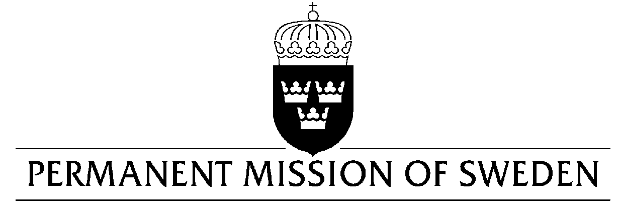
UN Human Rights Council

UPR 33rd session

Statement by Sweden in the interactive dialogue on Albania

Delivered by Second Secretary Clara Molin
Geneva, 6 May 2019 (speaking time 1:07 min, speaker no.1)

Mr. President,

Sweden welcomes the ongoing justice reform, which is vital to safeguard human rights in Albania. Sweden further supports the strengthening of human rights in Albania through our bilateral reform cooperation, including in the areas of the rights of the child, freedom of expression and gender equality. However, we encourage further efforts to ensure access to justice for all and to strengthen the respect, protection and fulfillment of human rights. Sweden would therefore like to make the following recommendations:

- To increase budget allocations from the central Government to enable the establishment of Ombudsman offices in all regions of the country.

- To ensure the full implementation of the Law on Measures against Violence in Family Relations through the development of bylaws, allocation of sufficient funding and training of staff to ensure adequate support to victims of violence.

- To ensure that mechanisms are in place to bring perpetrators, that have verbally or physically threatened or attacked journalists, to justice.

Sweden wishes Albania all success in the current review.

I thank you Mr. President.

