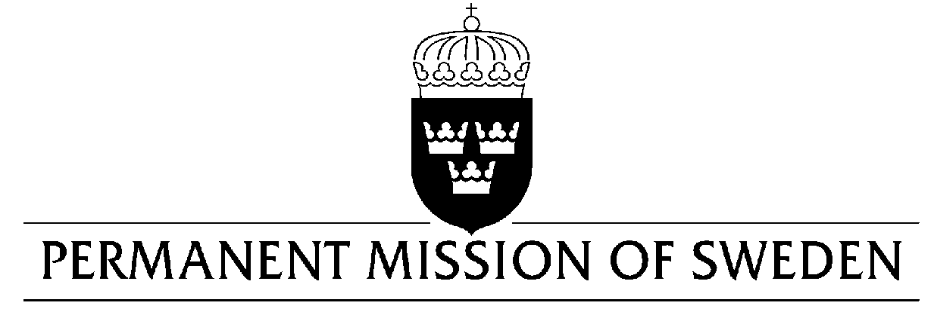
UN Human Rights Council

UPR 33rd session

Statement by Sweden in the interactive dialogue on the Democratic Republic of the Congo

Delivered by Ambassador Veronika Bard
Geneva, 7 May 2019 (speaking time 1:10 min)

Mr. President,

Sweden acknowledges progress in terms of adopting legislation complementarity with the Rome Statute, as well as in efforts to fight impunity and address cases of war crimes, including rape, sexual violence, and recruitment and use of child soldiers. Sweden also acknowledges positive steps taken in 2019 by the new President. However, Sweden remains deeply concerned over a number of human rights violations and abuses in the DRC and would like to make the following four recommendations:

- Intensify efforts to ensure that all alleged perpetrators of crimes against international human rights and humanitarian law are brought to justice.
- Adopt and promulgate the law fixing the implementation measures of the freedom to demonstrate, to ensure the freedoms of assembly and association in accordance with the Constitution and international obligations.
- Review the draft NGO and human rights defenders’ bills to ensure that they do not lead to restrictions on civil society.
- Allocate a budget for the implementation of the FARDC and PNC action plans to combat sexual violence.

Sweden wishes the DRC all success in the current review.

I thank you Mr. President.

