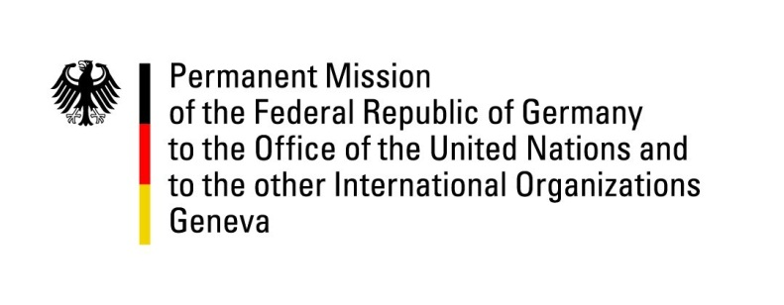

United Nations Human Rights Council

33rd Session of the UPR Working Group

Geneva, 10 May 2019

Recommendations and advance questions to
Qatar

Mr. President,

Germany welcomes that Qatar acceded to the International Covenant on Civil and Political Rights and the International Covenant on Economic, Social and Cultural Rights and acknowledges the considerable progress made in the reform of the labor law. At the same time, Germany expresses its concern about the reservations made to both Covenants.
Germany recommends:
- Lift reservations to the International Covenant on Civil and Political Rights and the International Covenant on Economic, Social and Cultural Rights and bring national legislation fully in line with both Covenants, especially in relation to the right to freedom from torture and other cruel, inhuman or degrading treatment or punishment, freedom of association and freedom from discrimination;
- Ensure that women are fully protected from discrimination and violence, including by criminalizing domestic violence against women, adopt legal measures to guarantee full gender equality, and withdraw reservations to the Convention on the Elimination of All Forms of Discrimination against Women;
- Respect the right to freedom of opinion and expression and refrain from imposing any undue restriction on this right, including with regard to the new draft media law;
- Bring the law on domestic workers in line with international standards, including ILO Convention 189 on domestic workers.

Thank you, Mr. President.

GERMAN ADVANCE QUESTIONS TO QATAR:
- What is the timeframe under which Qatar intends to implement the remainder of the labor law reform package?
- How and when will Qatar implement the broadening of the labor law reform to include domestic workers?
- In which legal context will Qatar ensure that domestic workers can complain regarding violence, including sexual and other abuses, without fear of harassment and potentially pursue legal proceedings?
- How does Qatar aim to achieve gender equality, in particular regarding citizenship laws that do not allow women to automatically pass on their nationality to their children?

