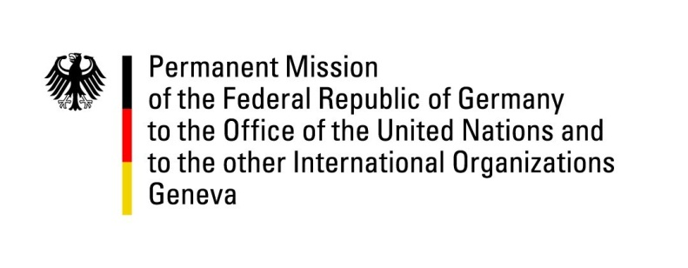

United Nations Human Rights Council

33rd Session of the UPR Working Group

Geneva, 08 May 2018

Recommendations and advance questions to
Portugal

Mr. President,

Germany appreciates Portugal’s commitment to promote and protect human rights, in particular regarding the fight against discrimination based on sexual orientation and gender identity and Germany welcomes the recently taken steps to combat domestic violence.
Germany would like to offer the following recommendations:
- Intensify efforts to prevent and combat domestic violence as well as
take specific steps to ensure investigations of all allegations of domestic violence and abuse.

- Continue efforts to overcome all kinds of discrimination based on gender or racial discrimination, specifically with regard to ongoing discrimination faced by Roma and people of African descent.

- Draft a National Action Plan on Business and Human Rights.

- Adopt comprehensive measures to address allegations of ill-treatment, the problem of overcrowding as well as the sanitary and health conditions in prisons.

Thank you, Mr. President.

ADVANCED QUESTIONS:
- How does Portugal assess the current situation with regard to child poverty and, in particular, the schooling situation of Roma children?
- How does Portugal assess the current situation with regard to homeless people? Which measures are foreseen to attend to their needs or to effectively remedy their situation?
- How does Portugal assess the current situation with regard to discrimination against Roma and people of African descent, in particular, with respect to access to adequate housing?
- How does Portugal assess the current situation with regard to the penal system, including overcrowding, violence as well as sanitary and health conditions?

