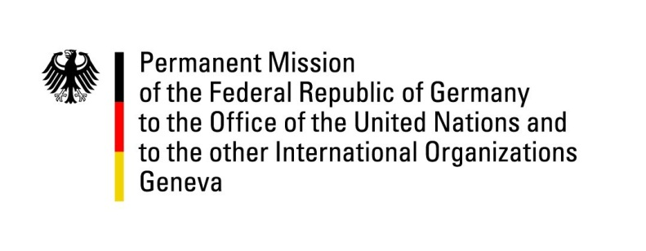

United Nations Human Rights Council

33nd Session of the UPR Working Group

Geneva, 6 May 2019

German questions and recommendations to
Norway

Thank you, Mr. President.

Germany welcomes the delegation of Norway to the third cycle of the UPR.

We commend the constitutional amendments to strengthen human rights protection, particularly the adoption of a new human rights catalogue, as well as the establishment of a national human rights institution in compliance with the Paris Principles. We further welcome the ratification of the Optional Protocol to the Convention on the Rights of the Child on the sale of children, child prostitution and child pornography, and the Council of Europe Istanbul Convention.

Germany recommends:
- Ratify the Optional Protocol to the Convention on the Rights of the Child on a communications procedure;
- Continue giving high priority to the issues of unaccompanied asylum seeking minors placed in asylum centers and protecting them from disappearing from reception centers and being exposed to the risk of becoming victims of human trafficking, exploitation or other crimes, including providing the necessary resources and enhancing established systems;
- Take effective measures to improve conditions for prisoners with psychological disabilities and serious mental health problems, including by providing full access to mental healthcare services within all prison facilities or limiting the use of isolation;
- Ratify the Optional Protocol to the Convention on the Rights of Persons with Disabilities.

Thank you, Mr. President.

