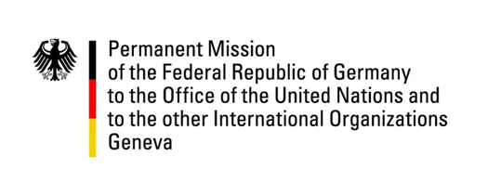

United Nations Human Rights Council
33rd Session of the UPR Working Group
Geneva, 15 May 2019

Germany’s Recommendations and Questions to
Nicaragua

Mr. President,

Germany welcomes Nicaragua to the UPR review. We commend Nicaragua’s engagement in negotiation talks with the opposition and strongly encourage Nicaragua’s government to continue their efforts in reaching a political settlement. Germany remains concerned about the human rights situation in the country and would like to offer the following recommendations:

- Ensure that members of the political opposition and civil society organizations as well as journalists are free to express their views and opinions and their right to freedom of assembly is also guaranteed;

- Implement measures to ensure the judiciary’s independence, including complying with established procedures on the selection and appointment of judicial personnel and working with the Special Rapporteur on the Independence of Judges and Lawyers to this end;

- Take immediate measures to address the high rates of femicide and sexual and domestic violence against women and children by promptly investigating and prosecuting such crimes, repealing legislative amendments that have weakened implementation of Act No. 779 and providing specialized support for victims;

- Decriminalize abortion at least in cases of pregnancies resulting from rape, incest or where the life or health of the mother is at risk.

Thank you Mr. President

Advanced Questions:

- What measures is the government of Nicaragua taking to restore impartiality and independence of its judiciary?
- How will Nicaragua ensure an impartial investigation regarding alleged human rights violations by police and parapolice forces since April 2018? What measures are being taken to prevent such violence in future?
- What concrete measures are being taken to reduce the high rates of femicide, domestic violence and child abuse? Why have legislative amendments that undermine the purpose of Act No. 779 been adopted? What measures are being taken to reduce the high rates of teen pregnancy?
- What measures is Nicaragua taking to protect vulnerable groups, including indigenous and LGBTI people, from oppression and discrimination?

