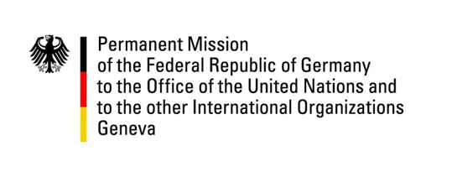

United Nations Human Rights Council

33rd Session of the UPR Working Group

Geneva, 9 May 2019

Germany’s Recommendations and Questions to
Dominica

Mr. President,

Germany welcomes Dominica to the UPR review.
We commend Dominica’s progress with regards to women’s rights and the protection of children against abuse with the passage in 2016 of the Sexual Offences Act.
Germany would like to make the following recommendations:
- Implement measures to eliminate violence and discrimination against women, including the amended Domestic Violence Act, strengthen the functioning of the Bureau of Gender Affairs and finalize and implement the National Policy and Action Plan for Gender Equality;
- Repeal all legislation and provisions that criminalize same-sex relations including Article 16 of the Sexual Offences Act and implement measures to effectively prevent discrimination and social stigmatization of individuals based on sexual orientation and gender identity;
- Outlaw all sentences of corporal punishment for children as well as life imprisonment for children under the age of 14. Ensure full compliance with international standards and take adequate measures to stop the persisting child abuse, in particular sexual abuse;
- Abolish the death penalty and ratify the Second Optional Protocol to the International Covenant on Civil and Political Rights.

Thank you, Mr. President

