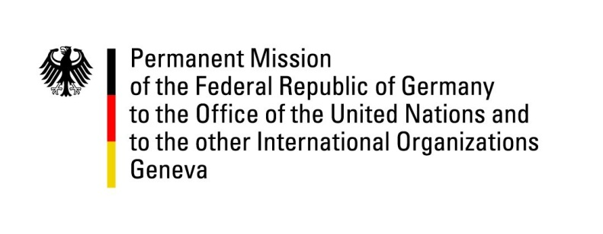

United Nations Human Rights Council

33nd Session of the UPR Working Group

Geneva, 7 May 2019

German questions and recommendations to
The Democratic Republic of Congo

Thank you, Mr. President.

Germany welcomes the delegation of the Democratic Republic of Congo to the third cycle of the UPR.

We commend the Democratic Republic of Congo for the release of political prisoners and encourage it to better protect the human rights of politically active citizens in the future. We furthermore commend the government for legal improvements introduced by the Family Code, which however remain to be implemented in many parts of the country.

Germany is concerned by human rights violations that occurred in the context of the parliamentary and presidential elections in December 2018, including restrictions of the freedoms of assembly and the freedom of speech as well as arbitrary arrests and even killings.

Germany recommends:

- Abolish the death penalty for all crimes and ratify the Second Optional Protocol in relation to Civil and Political Rights, aiming at the abolition of the death penalty;
- Take further measures to end the practices of child recruitment and child labour by making free school education and reintegration of child soldiers a first priority;
- Conduct regular inspections on FARDC missions to guarantee that international human rights standards and provisions of humanitarian law are met;
- Adopt and enforce a clear legal framework of the right to assembly, in line with international human rights standards, in order to avoid violations of the freedom of expression and peaceful assembly, such as criminalizing peaceful protesters;
- Take concrete measures to make women’s rights and gender equality a priority of government action, including by effectively implementing the law on parity and enforcing women’s representation in government and state institutions.

Thank you, Mr. President.

Advance questions:

- Which concrete measures does the government take in order to more effectively address the issue of recruitment and use of child soldiers?
- In how far will, by law and in practice, human rights defenders and journalists be better protected in future?
- What are the next planned steps in order to end impunity for human rights violations?

