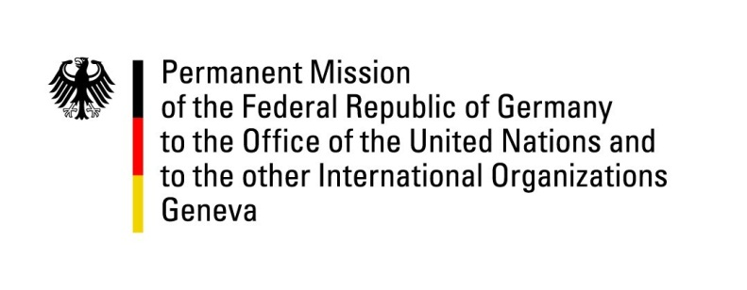

United Nations Human Rights Council

33rd Session of the UPR Working Group

Geneva, 9 May 2019

Recommendations and advance questions to
DPRK

Mr. President,

Germany welcomes the visit of the Special Rapporteur on rights of persons with disabilities to the DPRK. Some improvements for persons with disabilities have been made.
We recommend:
- Grant access and cooperate with all UN Special Procedures, in particular the Special Rapporteur on the situation of human rights in the DPRK;
- Give international humanitarian organizations access to provide assistance to detainees in all penitentiary facilities, including labor training camps (dallyeondae), prisons (gyohwaso) and political prison camps (gwanliso), allow family visits to all detainees, and establish rules regarding the treatment of detainees in accordance with international human rights standards;
- Take immediate and effective action to stop the use of torture and ill-treatment, including sexual violence, through proper procedural training, awareness campaigns and enactment of laws, especially for state security and policing organs;
- End the practice of unpaid or inadequately paid labor (dolkyokdae) and political mobilizations of the population, which in the case of minors hinder the access to quality education and development;
- End the social classification system “songbun” and related discriminations.

Thank you, Mr. President.

