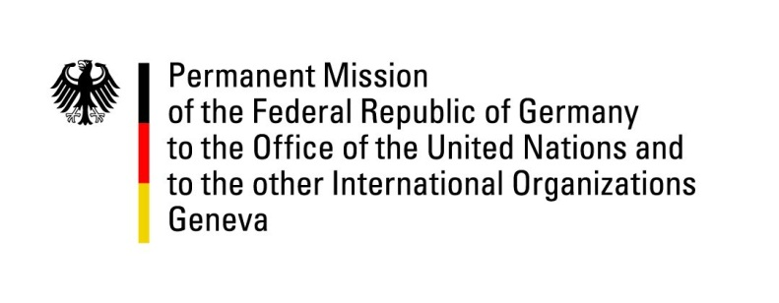

United Nations Human Rights Council

33rd Session of the UPR Working Group

Geneva, 07 Mai 2019

Recommendations and advance questions to
Côte d’Ivoire

Mr. President,
Germany welcomes the delegation of Côte d’Ivoire.
We commend Côte d’Ivoire for the progress made in promoting women’s rights and gender equality and for introducing the national strategy for the fight against gender-based violence in September 2014.

However, Germany is concerned about the human rights situation in prisons, especially with regard to children.

Germany offers the following recommendations:
- Continue to take effective action in protecting women and children from sexual violence by strengthening and implementing legislation against domestic violence and providing counselling services and safe places for victims;
- Better protect the rights of LGBTI persons, by expanding non-discrimination laws to include discrimination based on sexual orientation and gender identity and by abolishing homosexuality as aggravating circumstance as mentioned in Article 360 of the penal code;
- Reduce overcrowding in prisons and ensure that persons do not remain in pre-trial detention beyond the prescribed time limits;
- Continue to take effective measures in order to end child labour, for example in the agriculture and mining sectors;
- Ratify the Optional Protocol to the Convention against Torture and Other Cruel, Inhuman or Degrading Treatment or Punishment (OPCAT) and implement a national prevention mechanism and reporting scheme.

Thank you, Mr. President.

