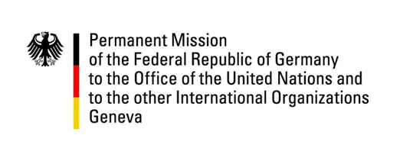

United Nations Human Rights Council
33rd Session of the UPR Working Group
Geneva, 13.05.2019

---
Germany’s Recommendations and Questions to
Costa Rica

Mr. President,

Germany welcomes Costa Rica to the UPR review and commends its efforts to advance human rights. We also recognize Costa Rica’s efforts to protect children, including the adoption of the Improper Relationships Act which we encourage to be effectively implemented.
Germany offers the following recommendations:

- Implement Indigenous Law 6172 to recognize and protect indigenous land and take the necessary measures to support and guarantee the indigenous people’s right to the restitution of their land as stipulated in Law 6172; update and pass the indigenous autonomy bill now pending for almost 25 years;

- Take strong measures to reduce the high rates of femicide and violence against women, including through the use of public campaigns and family programs and adopt clear guidelines for therapeutic abortion services, legalize abortion in cases of rape, incest or health hazards to the mother and prevent and sanction cases of obstetric violence against women;

- Implement measures to safeguard the rights, physical integrity and wellbeing of migrants and refugees, including fighting human trafficking and implementing public awareness campaigns.

Thank you, Mr. President

Advanced Questions:

- What measures are being taken to implement Indigenous Law 6172? What steps is Costa Rica taking to ensure indigenous people’s land rights?

- What is the status on the pending indigenous autonomy bill now pending for almost 25 years?

- What measures are being taken to reduce the high rates of domestic violence and femicide?

- Does the government of Costa Rica intend to legalize abortion in cases of rape, incest or health hazards to the mother? What steps are being taken to prevent and sanction cases of obstetric violence against women?

