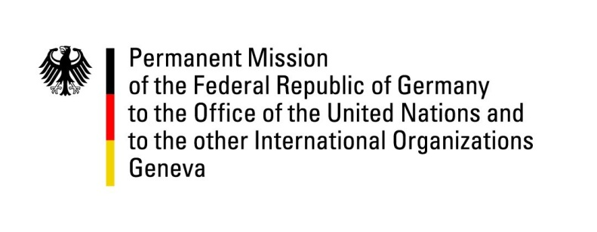

United Nations Human Rights Council

33rd Session of the UPR Working Group

Geneva, 10 May 2019

Recommendations and advance questions to
Brunei Darussalam

Mr. President,

Germany welcomes the de facto moratorium on the death penalty and its recent extension to the Syariah Penal Code Order.
We recommend:
- Decriminalize consensual same-sex conduct and repeal provisions in the Syariah Penal Code Order that are not compliant with international human rights norms;
- Guarantee the freedoms of expression, peaceful assembly and association, inter alia by repealing the Sedition Act;
- Maintain the current de facto moratorium with a view to formally abolishing the death penalty;
- Allow women to enjoy equal rights in conferring citizenship to their children and spouses.

Germany remains concerned about the Syariah Penal Code Order, which prescribes the death penalty and corporal punishments for specific acts identified as offences in the Code.
Thank you, Mr. President.

GERMAN ADVANCE QUESTIONS TO BRUNEI DARUSSALAM:
- How does Brunei Darussalam intend to safeguard the human rights of LGBTI persons?
- How will Brunei Darussalam assure that the application of the Syariah Penal Code Order (SPCO) does not lead to human rights violations, such as torture or discrimination?
- How will Brunei Darussalam guarantee the freedom of opinion, also with regard to the SPCO?
- What steps are taken by Brunei Darussalam to prohibit all corporal punishment of children, including as a sentence for a crime and under the SPCO?
- How does Brunei Darussalam aim to achieve gender equality, in particular regarding the conferral of nationality onto children and spouses?

