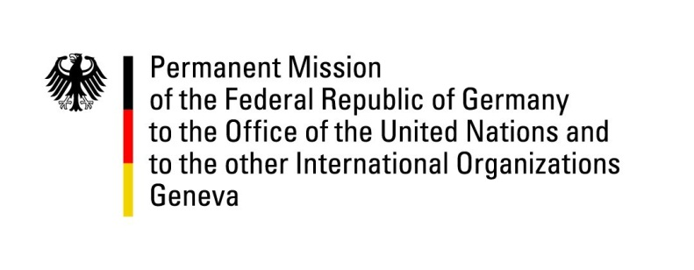

United Nations Human Rights Council

33nd Session of the UPR Working Group

Geneva, 8 May 2019

Recommendations and advance questions to
Bhutan

Mr. President,
Germany commends Bhutan for its commitment to democracy and the successful parliamentary elections in 2018, its progress towards preventing violence against women and children and for the growing role of its civil society.

Germany recommends:
- Ratify the core international human rights treaties, most notably ICCPR, ICESCR and CAT;
- Continue to adopt measures to combat violence against women and children, including by implementing and closely monitoring the impact of the Domestic Violence Prevention Act;
- Decriminalize consensual same-sex conduct by revoking or amending sections 213 and 214 of the Penal Code;
- Continue efforts, together with Nepal, to find a lasting solution to the situation of refugees formerly resident in Bhutan and currently living in Nepal.

Thank you, Mr. President.

