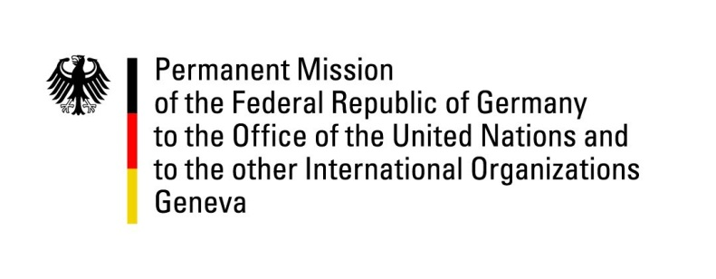

United Nations Human Rights Council

33nd Session of the UPR Working Group

Geneva, 6 May 2019

German questions and recommendations to
Albania

Thank you, Mr. President.

Germany welcomes the delegation of Albania. We appreciate the efforts undertaken to implement the recommendations given in the previous cycles of the UPR.

We highly commend the progress made with regard to the implementation of the judicial reform, aimed at strengthening the independence, efficiency and accountability of state judicial institutions and at fighting corruption. At the same time, we remain concerned about the situation with regard to freedom of expression and independence of the media, protection of minorities, and individual property rights.

Germany recommends to:

- Continue efforts to strengthen the protection of minorities and combat discrimination, in particular through additional legislation to make the existing law on the protection of minorities effective and bring it in conformity with international human rights standards;
- Promote and ensure equal access to education for all children, particularly focusing on children of minority groups;
- Better protect victims of domestic violence, in particular women and children;
- Take effective measures to strengthen the freedom of expression and independence of the media, including to ensure a safe environment for investigative journalists and their protection from intimidation and attacks as well as to improve their working conditions;
- Protect and strengthen the individual real estate property rights through adopting a balanced legislation that would provide for a fair settlement between the original owners, those who have received property titles within the process of legalization, and state interests.

Thank you, Mr. President.

