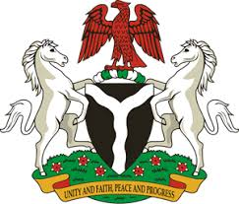
Please check against delivery
HUMAN RIGHTS COUNCIL
33RD SESSION OF THE WORKING GROUP OF THE UPR
REVIEW OF NORWAY
6TH MAY, 2019
STATEMENT BY NIGERIA
Mr President,
Nigeria welcomes the delegation of Norway to the presentation of the country’s Third Cycle UPR National Report. We commend the Government of Norway for its cooperation with human rights mechanisms, and its efforts in implementing the previous recommendations.
2. We applaud the Government of Norway for its commitment to the promotion and protection of human rights and fundamental freedoms. Nigeria notes with encouragement, Norway’s action plan against human trafficking and the protection of the rights of victims of human trafficking. We also commend the country’s policy on integration of immigrants.
3. In the spirit of constructive dialogue, Nigeria wishes to offer the following recommendations to Norway:
- Not to relent in its efforts to combat hate speech and other hate crimes; and
- To continue with it efforts in combating human trafficking, and the protection of the rights of victims of human trafficking.
4. In conclusion, we wish Norway every success in its review process.
I thank you Mr President.
******

