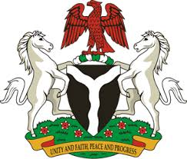
Please check against delivery
HUMAN RIGHTS COUNCIL
33RD SESSION OF THE WORKING GROUP OF THE UPR
REVIEW OF THE STATE OF QATAR
15TH MAY, 2019
STATEMENT BY NIGERIA
Mr Vice President,
Nigeria warmly welcomes the delegation of the State of Qatar to the presentation of its National Report for the Third Cycle UPR, and thanks them for the comprehensive update provided today. We commend the Government of Qatar for its commitment to the promotion and protection of human rights, and its continued cooperation with human rights mechanisms, as well as its efforts in implementing the previous recommendations.
2. W note with appreciation the various efforts by the Government of Qatar in strengthening its legal and institutional frameworks in the field of human rights, and the measures adopted for the protection and empowerment of women and other vulnerable groups. The country’s efforts in combatting human trafficking and protecting the rights of victims of human trafficking are noteworthy.
3. While acknowledging Qatar’s efforts in the field of human rights, and in the spirit of constructive dialogue, Nigeria wishes to recommend the following to Qatar:
- To scale up its efforts in combatting human trafficking, and the protection of victims of human trafficking; and
- To sustain its commitment to the promotion and protection of human rights, especially the rights of migrant workers.
4. Finally, we wish Qatar a very successful review process.
I thank you Mr Vice President.
******

