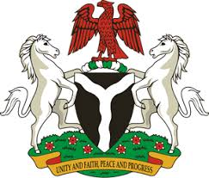
Please check against delivery
HUMAN RIGHTS COUNCIL
33RD SESSION OF THE WORKING GROUP OF THE UPR
REVIEW OF PORTUGAL
8TH MAY, 2019
STATEMENT BY NIGERIA
Madam Vice President,
Nigeria welcomes the delegation of Portugal to the presentation of the country’s Third Cycle UPR National Report, and thanks them for the update provided today. We commend the Government of Portugal for its cooperation with human rights mechanisms, and its efforts in implementing the recommendations accepted during the previous review.
2. We applaud the Government of Portugal for the adoption of numerous measures to prevent and combat racism, racial discrimination, xenophobia and intolerance, as well as hate speech. The country’s policy on the integration of migrants and marginalised groups are noteworthy. We also commend Portugal for its efforts in combatting human trafficking and the protection of victims of human trafficking.
3. In the spirit of constructive dialogue, Nigeria wishes to offer the following recommendations for the consideration of Portugal:
- Not to relent in its efforts to prevent and combat racism, racial discrimination, xenophobia and intolerance, as well as hate speech; and
- To continue with it efforts in protecting the rights of migrants, combatting human trafficking and protecting the rights of victims of human trafficking.
4. To conclude, we wish Portugal every success in its review process.
I thank you Madam Vice President.
******

