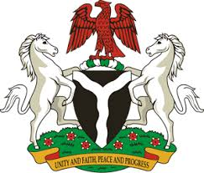
Please check against delivery
HUMAN RIGHTS COUNCIL
33RD SESSION OF THE WORKING GROUP OF THE UPR
REVIEW OF REPUBLIC OF NICARAGUA
15TH MAY, 2019
STATEMENT BY NIGERIA
Madam Vice President,
Nigeria welcomes the delegation of the Republic of Nicaragua to the presentation of the country’s National Report for the Third Cycle UPR. We commend the Government of Nicaragua for its continued cooperation and engagement with human rights mechanisms, and its efforts in implementing the recommendations it accepted during the previous review.
2. We note Nicaragua’s efforts at improving the country’s economic growth, aimed at eradicating extreme poverty. We applaud the country’s efforts in combatting human trafficking and its policy on migration.
3. While acknowledging the country’s efforts in upholding human rights, Nigeria wishes to offer the following recommendations to Nicaragua:
- To sustain its efforts in combatting human trafficking, and protecting the rights of victims of human trafficking, as well as the rights of migrants; and
- To continue its efforts at enhancing the socio-economic well-being of its people.
4. To conclude, we wish Nicaragua every success in its review process.
I thank you Madam President.
******

